William Mitchell
CpmA and 80a scaffolding proteins interaction in Staphylococcus aureus
Introduction
SaPls are mobile superantigen-( microbial products that have the ability to promote massive activation of immune cells, leading to the release of inflammatory mediators that can ultimately result in hypotension, shock, organ failure and death)( Langley et al )carrying pathogenicity islands(Pathogenicity islands (PAIs) are distinct genetic elements on the chromosomes of a large number of bacterial pathogens. PAIs encode various virulence factors and are normally absent from non-pathogenic strains of the same or closely related species. PAIs are considered to be a subclass of genomic islands that are acquired by horizontal gene transfer via transduction, conjugation and transformation, and provide ‘quantum leaps’ in microbial evolution (Gal-Mor, O. , Finlay))that are integrated at discrete sites within the genome of S. aureus. These mobile genetic elements can move between S. aureus cells by using helper phages (Dearborn et. a). Helper phages provide all the necessary gene products for particle formation when using phagemid vectors. They are mutated wild‐type phage containing the whole genome, with a defective origin of replication or packaging signal, and hence, are inefficient in self‐packaging (Encyclopedic Reference of Genomics and Proteomics in Molecular Medicine). When a helper phage infects the same host cell that is already occupied by the SaPl, the SaPl excises from the host genome and replicates. The helper phage provides the proteins the SaPl is missing to complete its life cycle (Damle et. al). Each SaPl has a certain helper phage or phages that allow SaPl dispersal. One example is S. aureus SaPl1. This particular SaPl is responsible for the spread of toxins, including the one that can cause toxic shock syndrome, a rare life threatening disease (Damle et. al). SaPl1’s helper is phage 80a. The Sapl highjacks the phage 80a to use it for reproduction. The redirection of the capsid size assists in helper phage exploitation. The smaller capsid formed in the presence of SaPl1 will fit only the genome of SaPl1; the genome of the phage 80a is too large to fit the smaller capsid (Christie, Dokland).
CpmA and CpmB are the two SaPl1 proteins responsible for the smaller capsid size (Poliakov et al). In a previous experiment, it was shown for efficient capsid size reproduction both proteins need to be present. With the deletion of CmpA there were no small capsids formed. However with the deletion of CmpB, approximately 3% of the capsids that formed were small. In yet another experiment, results showed that CpmB has the characteristics of an alternate scaffold protein that interacts with the major structural protein that forms the capsid (Damle et. al).
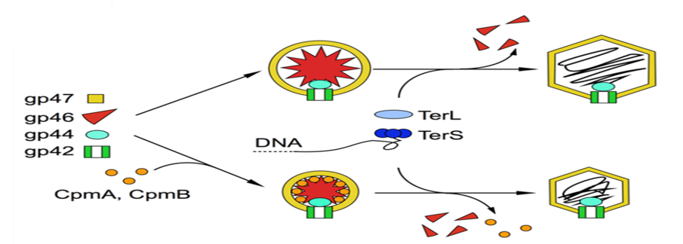
Major capsid
Scaffold
Minor capsid
portal

Hypothesis:
CpmA protein interacts directly with phage scaffold protein to allow for the formation of small capsids in the absence of CpmB protein.
Experimental Aim:
This experiment will demonstrate an interaction between the proteins by co-purification.
Methods:
Histidine
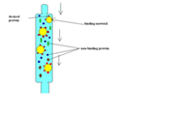
I propose adding a 6X-histidine tag (His6) to the CmpA protein and immobilizing it on a nickel column. The His6 tag will stick to the nickel column and any proteins that are interacting with CpmA will remain attached to CpmA (Liu et. . al) The following procedural steps are depicted with a brief description to accomplish the stated aim. First, two plasmids will be made from plasmid pPD22 (Spilman et al), an E. coli –S. aureus shuttle plasmid (plasmid that carries the modification into the cell) which encodes the 80a portal, minor capsid, scaffold, and major capsid proteins. The plasmids will be modified so the DNA sequence coding for the protein CpmA and the His6 tag will be added. One plasmid will have the His6 at the N-terminus and the other will have it at the C-terminus of the sequence for the CpmA protein. This will be done so that the possibility for the histidine tag interacting with the active region of CpmA will be minimized (Spilman et al). The DNA sequences for insertion will be made by PCR from SaPl1 DNA using primers with ends that introduce the restriction sites for cloning into pPD22 and the His6 tag. After ligation, the modified plasmids will be introduced into E. coli by electroporation and allowed to grow. Electroporation is a process that put an electric field across the cell membrane which causes disruption in the cell membrane that will allow for plasmid insertion. Candidate plasmids will be purified and in the correct insertions will be verified by DNA sequencing. The plasmid will then be introduced in S. aureus strain SA178RI by electroporation. Cells will be grown to mid-log phase (OD=0.5) and induced with 0.5mM IPTG to allow expression from the plasmid, as described in (Spillman et al). After 4 hours, cells will be harvested by centrifugation, resuspended in buffer and lysed in a bead beater with 50ug/ml lysostaphin. Then the Lysate will be clarified by centrifugation, and applied to a nickel-NTA column. The column will be washed with buffer solution 2 to 3 times to get rid of any unwanted proteins. The only thing that should be left bound is the CpmA and any proteins interacting with CpmA. The column is then washed with imidazole, which has a higher affinity for the nickel resin than histidine has and displaces the CpmA protein. After collecting the protein eluted from the column, samples on run on SDS-polyacryamide gel electrophoresis to determine the size of the protein or proteins. There should be one or more bands in the gel. One should be CpmA the others will be the protein or proteins that are interacting with CpmA. Then the bands are cut out of the gel and mass spec is performed on the samples. Mass spec breaks up the proteins in to smaller sequences with the use of trypsin that breaks the protein at lysine and arginine. Each amino acid has a specific weight so therefore the sequences can be determined but not the order. This will be followed with bioinformatics analysis to cross check databases to determine the identity of the proteins.
Discussion:
In summary, the results of this experiment will determine if there is protein interaction between CpmA and 80a scaffolding proteins, or any other proteins encoded in the capsid gene cluster. This will lead to a greater understanding of how helper bacteriophages contribute to SaPl1 propagation. Increased understanding of this process will lead to improved treatments for S. aureus infection that could block the spread of these pathogenicity islands.
CpmA
Works Cited
“The Staphylococcus aureus Pathogenicity Island 1 Protein gp6 Functions as an Internal Scaffold during Capsid Size Determination”By: Dearborn, Altaira D., Michael S. Spilman, Priyadarshan K. Damle, Jenny R. Chang, Eric B. Monroe, Jamil S. Saad, Gail E. Christie, and Terje Dokland.Journal of Molecular Biology
"Pirates of the Caudovirales." Christie, Gail E., and Terje Dokland .Virology 434.2 (2012): 210-21. Science Direct. Web. 30 Nov. 2014. <http://www.sciencedirect.com.proxy.library.vcu.edu/science/article/pii/S0042682212005363>
“The roles of SaPI1 proteins gp7 (CpmA) and gp6 (CpmB) in capsid size determination and helper phage nterference”By: Damle, Priyadarshan K., Erin A. Wall, Michael S. Spilman, Altaira D. Dearborn, Geeta Ram, Richard P. Novick, Terje Dokland, and Gail E. Christie.Virology
“Capsid Size Determination by Staphylococcus aureus Pathogenicity Island SaPI1 Involves Specific Incorporation of SaPI1 Proteins into Procapsids”By: Poliakov, Anton, Jenny R. Chang, Michael S. Spilman, Priyadarshan K. Damle, Gail E. Christie, James A. Mobley, and Terje Dokland.Journal of Molecular Biology
“Assembly of bacteriophage 80α capsids in a Staphylococcus aureus expression system”By: Spilman, Michael S.,Priyadarshan K. Damle, Altaira D. Dearborn, Cynthia M. Rodenburg, Jenny R. Chang, Erin A. Wall, Gail E. Christie, and Terje Dokland.Virology
"Nickel Nanoparticle Decorated Graphene for Highly Selective Isolation of Polyhistidine-tagged Proteins." Liu, Jia-Wei, Ting Yang, Lin-Yu Ma, Xu-Wei Chen, and Jian-Hua Wang Nanotechnology 24.Iopscience.iop.org (2013): 505704. Iopscience. Nanotechnology. Web. 30 Nov. 2014. <http://iopscience.iop.org.proxy.library.vcu.edu/0957-4484/24/50/505704/pdf/0957-4484_24_50_505704.pdf>.
"Mobilization of Pathogenicty Islands by Staphylococcus Arureus Strain Newman Bacteriophages." Dearborn, Altaira D., and Terjie Dokland Bacteriophage 2.2 (2012): 70-78. Print
Gal-Mor, O. and Finlay, B. B. (2006), Pathogenicity islands: a molecular toolbox for bacterial virulence. Cellular Microbiology, 8: 1707–1719. doi: 10.1111/j.1462-5822.2006.00794.x
Langley, Ries J, and Renno, Toufic(Nov 2011) Superantigens. In: eLS. John Wiley & Sons Ltd, Chichester. http://www.els.net [doi: 10.1002/9780470015902.a0001216.pub2]
Encyclopedic Reference of Genomics and Proteomics in Molecular Medicine.2006, p 753, Springer Berlin Heidelberg http://link.springer.com/referenceworkentry/10.1007%2F3-540-29623-9_7290

